### **Communities**

**Question 1**:

For the following graph:

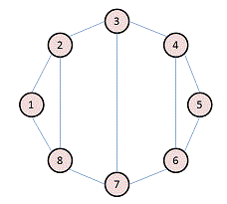

Write the adjacency matrix A, the degree matrix D, and the Laplacian matrix L. For each, find the sum of all entries and the number of nonzero entries.

Answer:

Adjacency Matrix (A):

|  |  |  |  |  |  |  |  |  |
| --- | --- | --- | --- | --- | --- | --- | --- | --- |
|  | 1 | 2 | 3 | 4 | 5 | 6 | 7 | 8 |
| 1 | 0 | 1 | 0 | 0 | 0 | 0 | 0 | 1 |
| 2 | 1 | 0 | 1 | 0 | 0 | 0 | 0 | 1 |
| 3 | 0 | 1 | 0 | 1 | 0 | 0 | 1 | 0 |
| 4 | 0 | 0 | 1 | 0 | 1 | 1 | 0 | 0 |
| 5 | 0 | 0 | 0 | 1 | 1 | 0 | 0 | 0 |
| 6 | 0 | 0 | 0 | 1 | 1 | 0 | 1 | 0 |
| 7 | 0 | 0 | 1 | 0 | 0 | 1 | 0 | 1 |
| 8 | 1 | 1 | 0 | 0 | 0 | 0 | 1 | 0 |

No of non-zero entries = 22; Sum of all entries = 22

Degree Matrix (D):

|  |  |  |  |  |  |  |  |  |
| --- | --- | --- | --- | --- | --- | --- | --- | --- |
|  | 1 | 2 | 3 | 4 | 5 | 6 | 7 | 8 |
| 1 | 2 | 0 | 0 | 0 | 0 | 0 | 0 | 0 |
| 2 | 0 | 3 | 0 | 0 | 0 | 0 | 0 | 0 |
| 3 | 0 | 0 | 3 | 0 | 0 | 0 | 0 | 0 |
| 4 | 0 | 0 | 0 | 3 | 0 | 0 | 0 | 0 |
| 5 | 0 | 0 | 0 | 0 | 2 | 0 | 0 | 0 |
| 6 | 0 | 0 | 0 | 0 | 0 | 3 | 0 | 0 |
| 7 | 0 | 0 | 0 | 0 | 0 | 0 | 3 | 0 |
| 8 | 0 | 0 | 0 | 0 | 0 | 0 | 0 | 3 |

**No of non-zero entries = 8; Sum of all entries = 8**

**Laplacian Matrix L = D - A**

|  |  |  |  |  |  |  |  |  |
| --- | --- | --- | --- | --- | --- | --- | --- | --- |
|  | **1** | **2** | **3** | **4** | **5** | **6** | **7** | **8** |
| **1** | **2** | **-1** | **0** | **0** | **0** | **0** | **0** | **-1** |
| **2** | **-1** | **3** | **-1** | **0** | **0** | **0** | **0** | **-1** |
| **3** | **0** | **-1** | **3** | **-1** | **0** | **0** | **-1** | **0** |
| **4** | **0** | **0** | **-1** | **3** | **-1** | **-1** | **0** | **0** |
| **5** | **0** | **0** | **0** | **-1** | **-1** | **3** | **-1** | **0** |
| **6** | **0** | **0** | **0** | **-1** | **-1** | **3** | **-1** | **0** |
| **7** | **0** | **0** | **-1** | **0** | **0** | **-1** | **3** | **-1** |
| **8** | **-1** | **-1** | **0** | **0** | **0** | **0** | **-1** | **3** |

**No of non-zero entries = 30; Sum of all entries = 0**

**Question 2**:

Consider the following undirected graph (i.e., edges may be considered bidirectional):

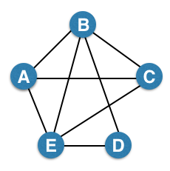

Run the "trawling" algorithm for finding dense communities on this graph and find all complete bipartite subgraphs of types K3,2 and K2,2. Note: In the case of K2,2, we consider {{W, X}, {Y, Z}} and {{Y, Z}, {W, X}} to be identical.

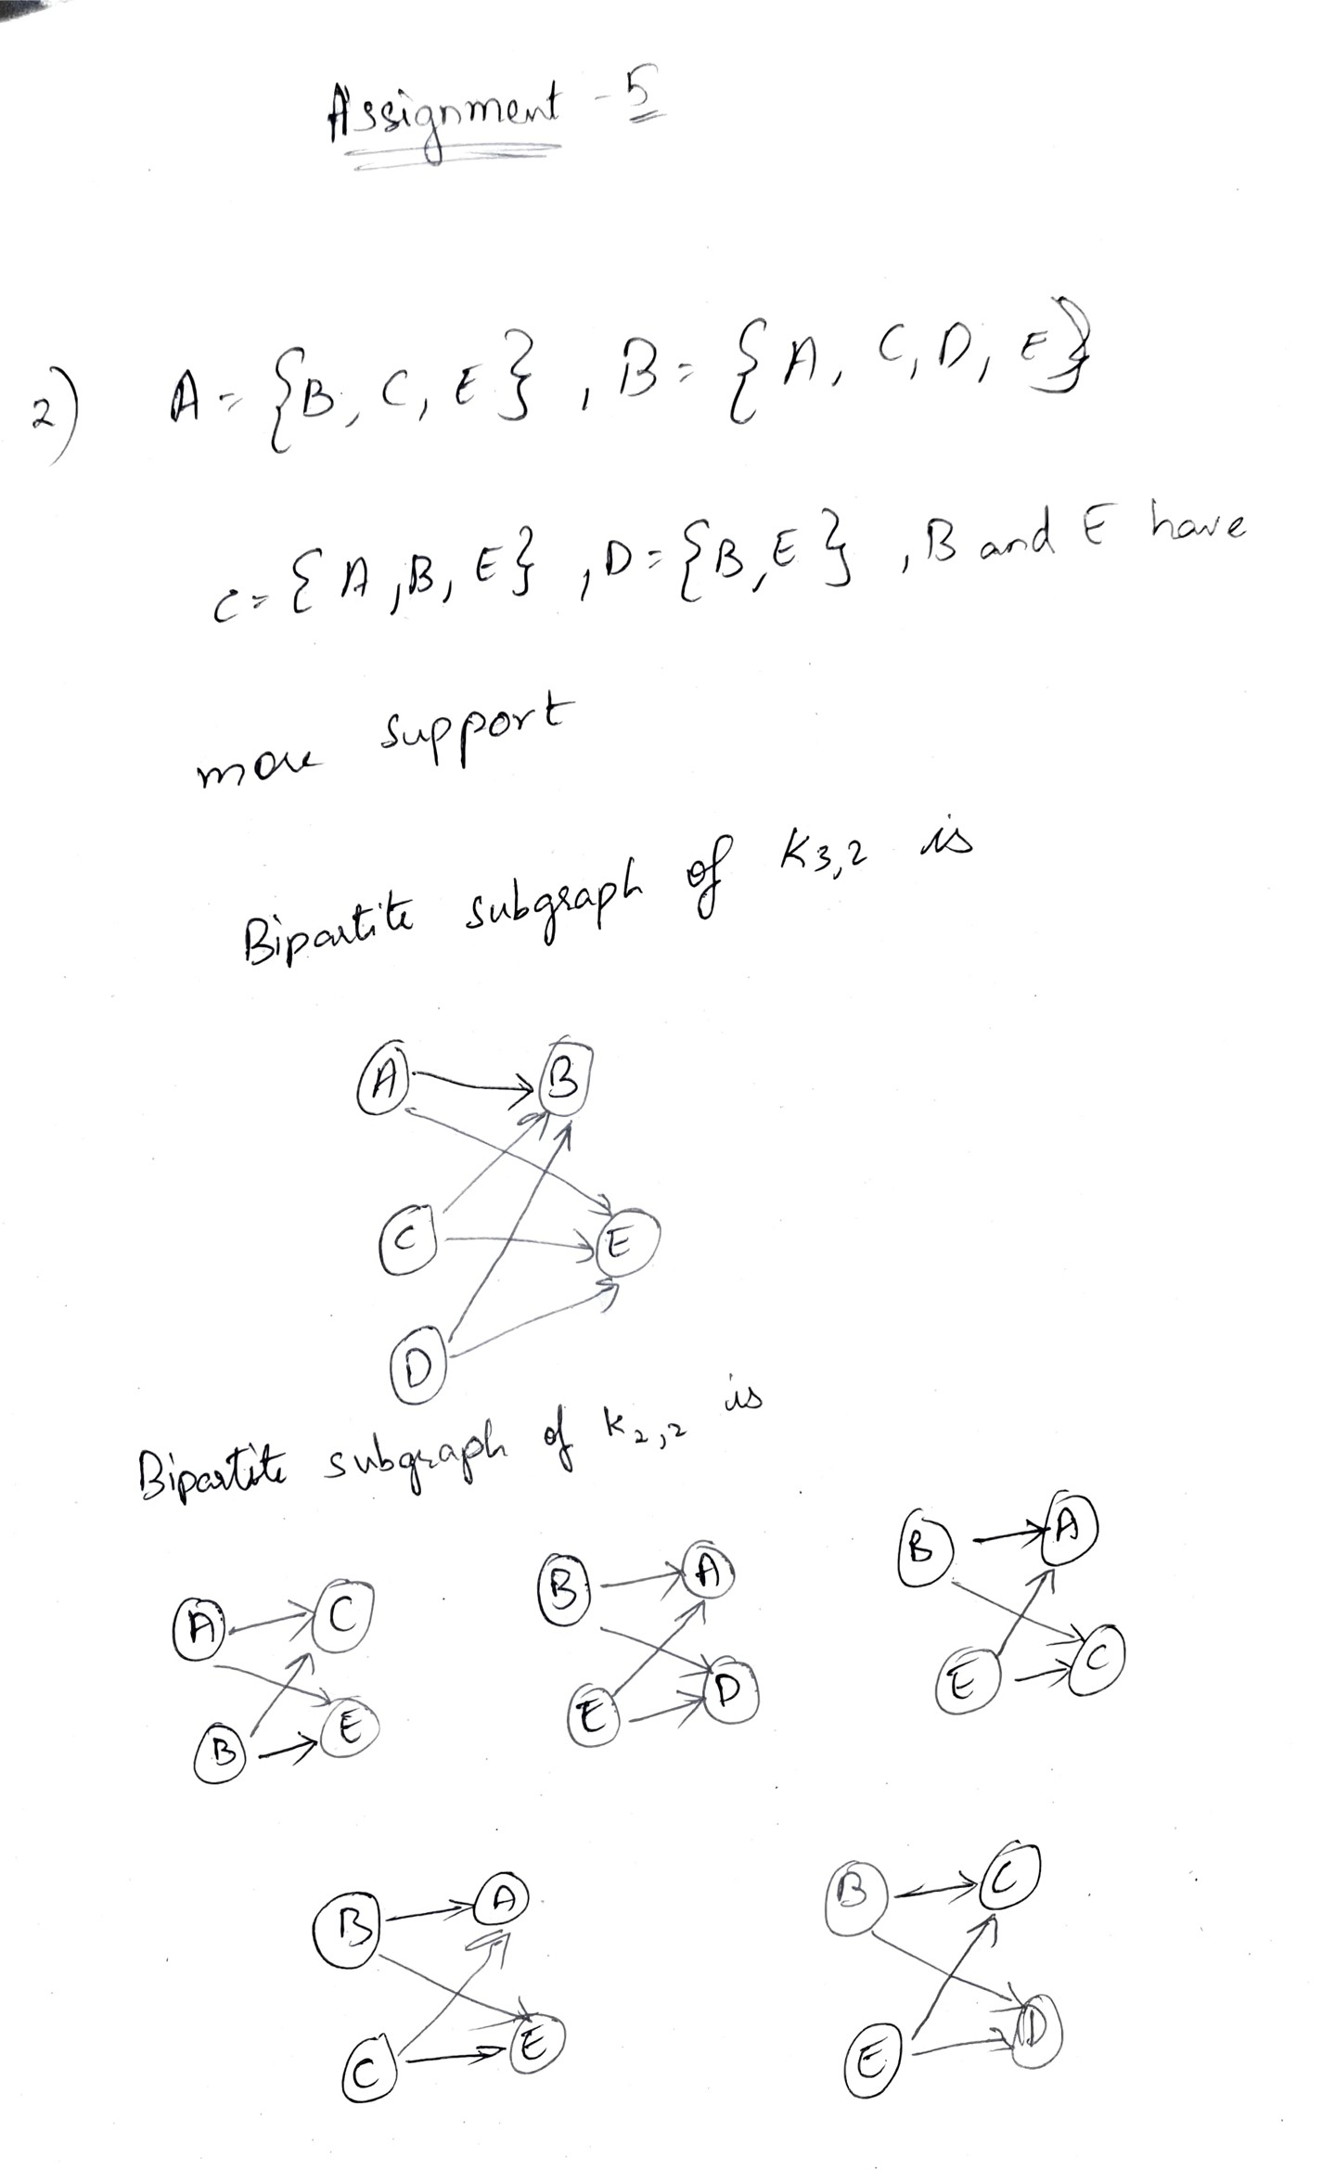

**Question 3**:

We fit AGM to the network on the left, and found the parameters on the right:

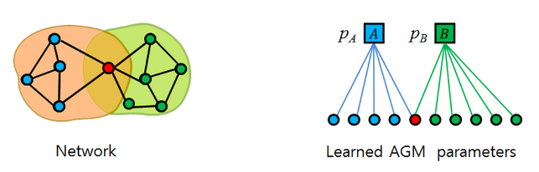

Find the optimal values for pA and pB.

Answer:

Pa = Number of edges in the network / Total possible number of edges = 7/5c2 = 7/10.

Pb = Number of edges in the network / Total possible number of edges = 9/6c2 = 9/15.